**1. Verify Installation**



**2. Docker Image**

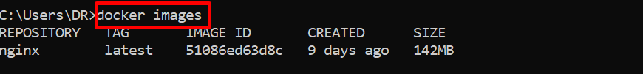

**3. Running Containers**

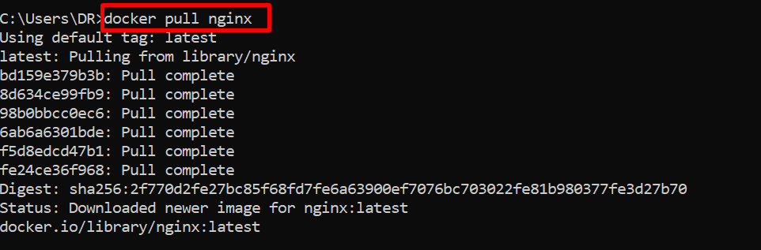

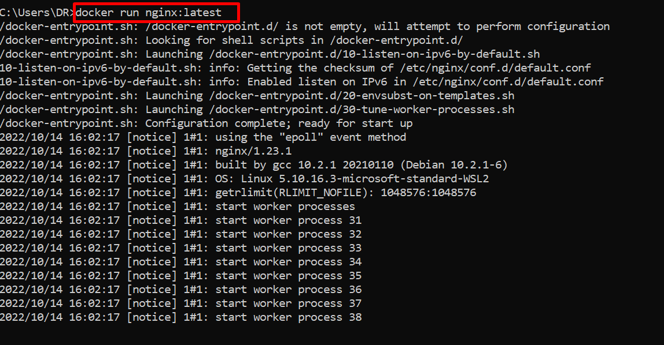

Docker run nginx:latest by this command editor be hang

Run container in backend





Run container by desire port

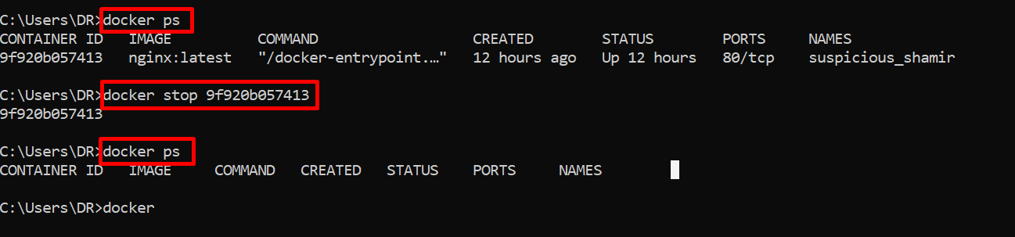

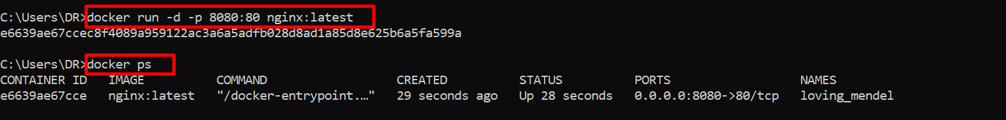

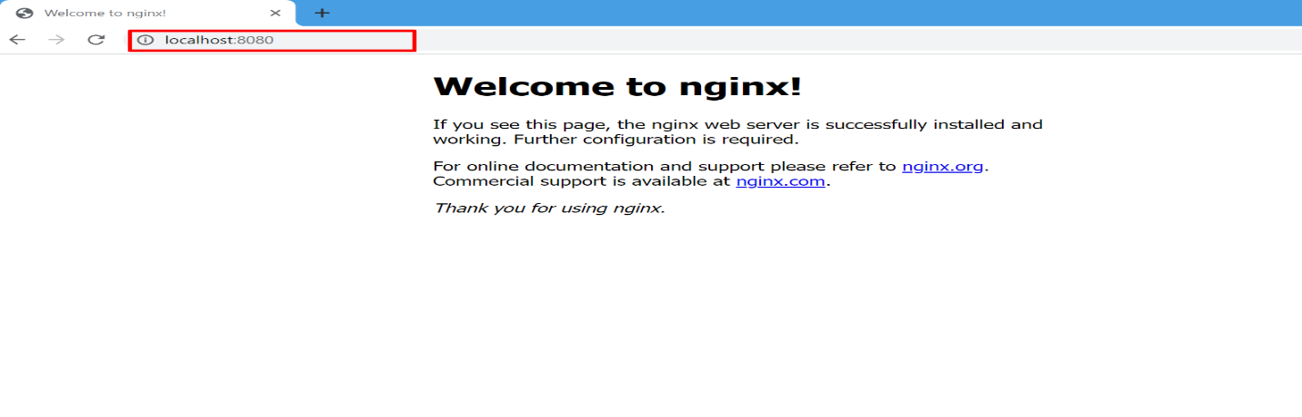

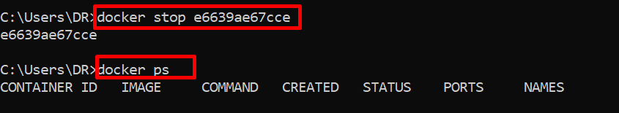

4. Exposing Multiple Ports

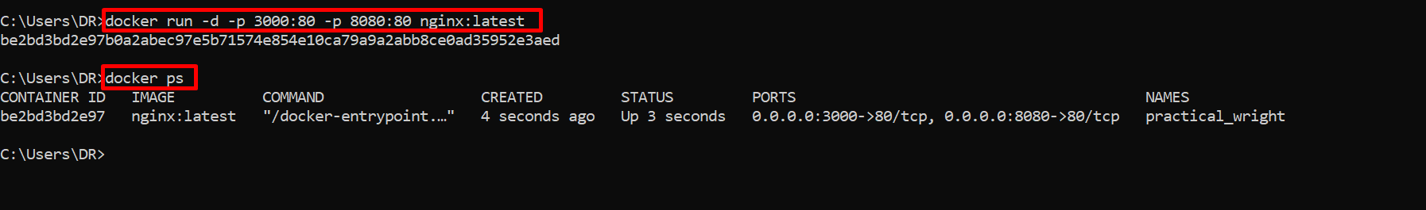

5. Mangaging Containers

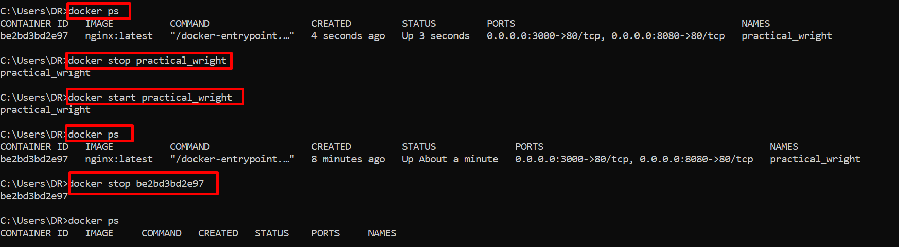

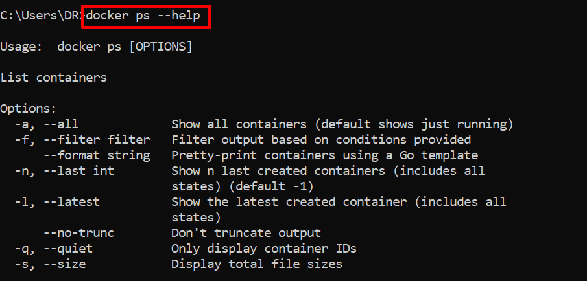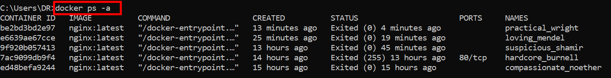

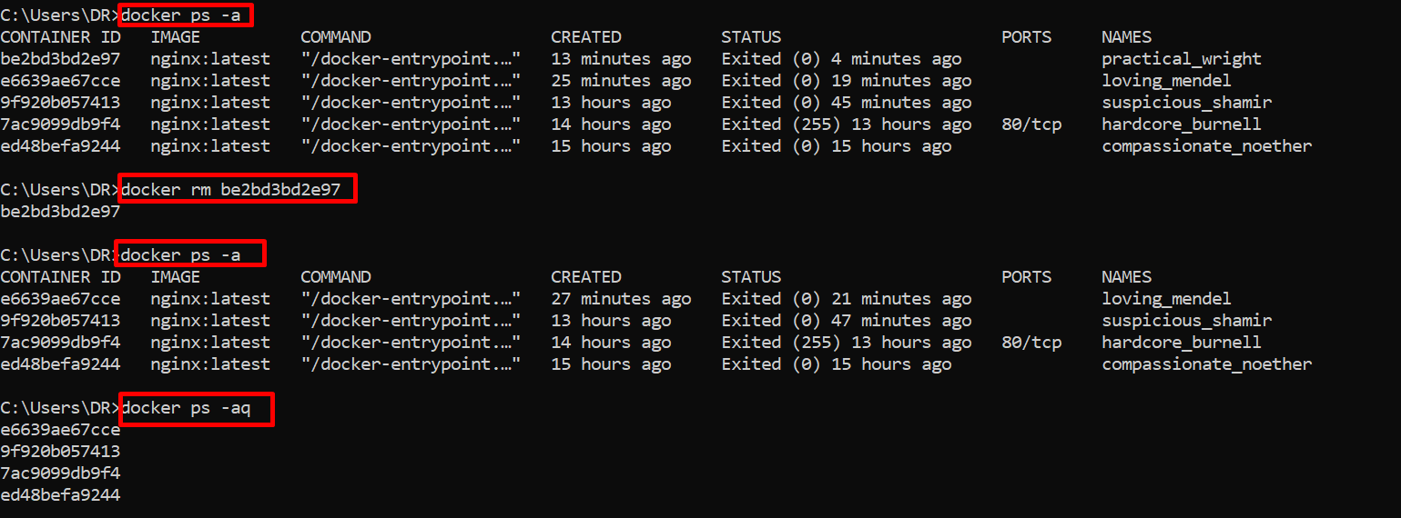

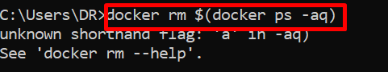

Solution:

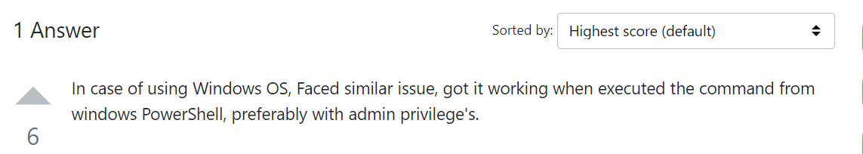

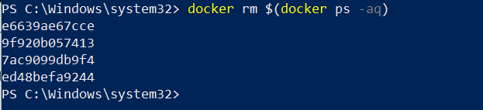

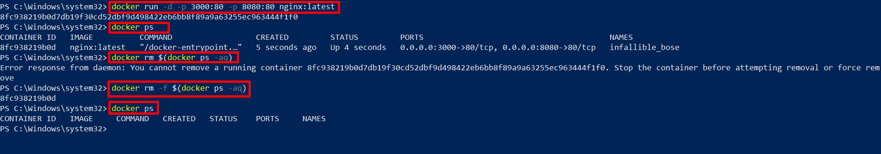

6. Naming Container

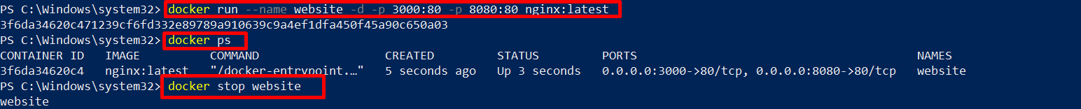



7. Docker ps

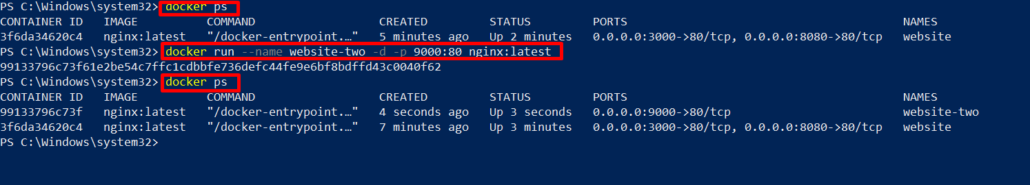

Formating

docker ps --format="ID\t{{.ID}}\nNAME\t{{.Names}}\nIMAGE\t{{.Image}}\nPORTS\t{{.Ports}}\nCOMMAND\t{{.Command}}\nCREATED\t{{.CreatedAt}}\nSTATUS\t{{.Status}}\n"

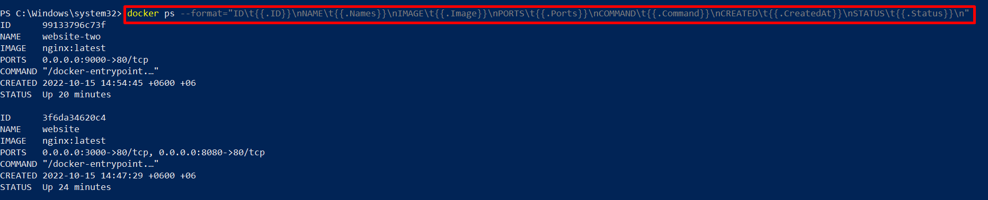

In windows set Environment Variable from powershell

PS C:\Windows\system32> $Env:FORMAT ="ID\t{{.ID}}\nNAME\t{{.Names}}\nIMAGE\t{{.Image}}\nPORTS\t{{.Ports}}\nCOMMAND\t{{.Command}}\nCREATED\t{{.CreatedAt}}\nSTATUS\t{{.Status}}\n"

In linux set Environment Variable

export FORMAT ="ID\t{{.ID}}\nNAME\t{{.Names}}\nIMAGE\t{{.Image}}\nPORTS\t{{.Ports}}\nCOMMAND\t{{.Command}}\nCREATED\t{{.CreatedAt}}\nSTATUS\t{{.Status}}\n"

Docker ps reference: https://docs.docker.com/engine/reference/commandline/ps/

8. Docker Volume

Mount local volume with docker container

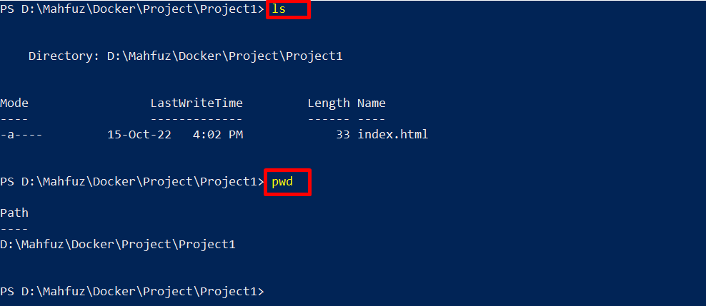

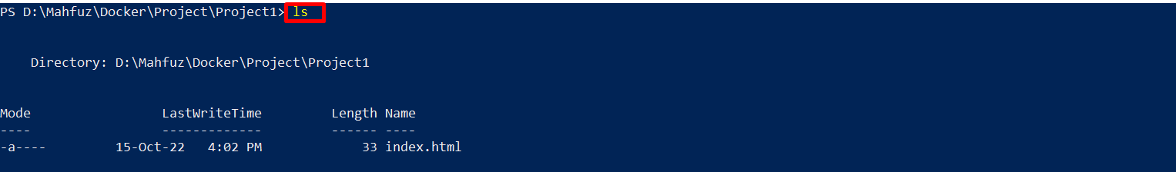

Read Only mode volume

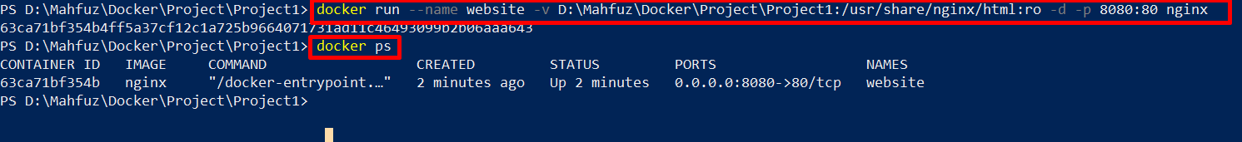

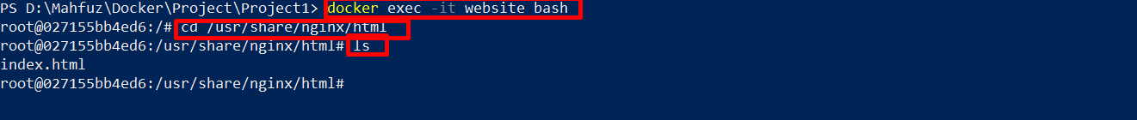

Read write mode volume

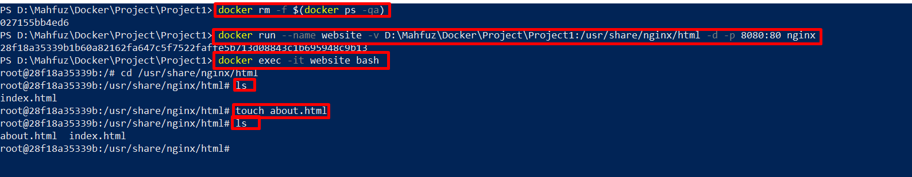

Sharing volumes between containers

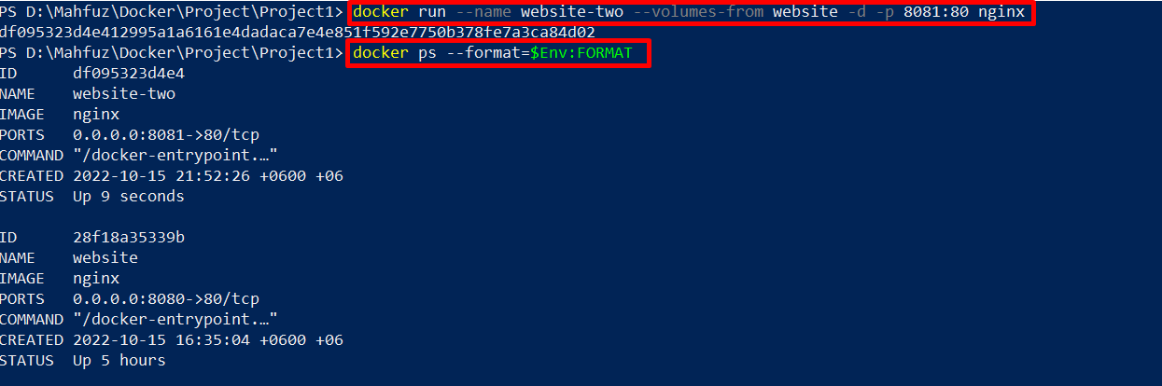

9. Dockerfile

FROM nginx:latest

ADD . /usr/share/nginx/html

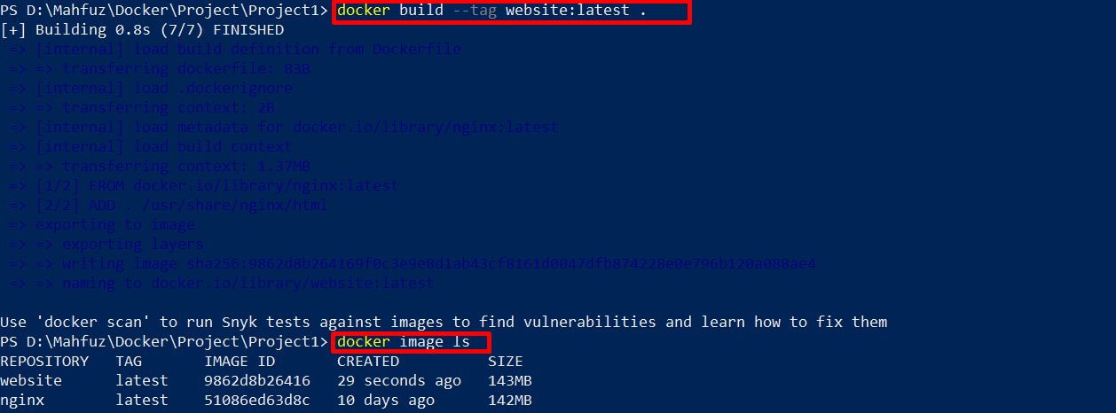

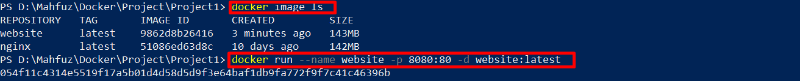

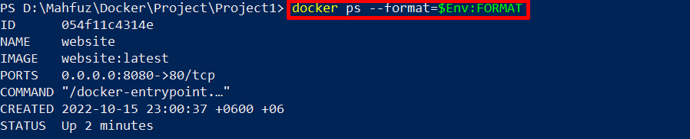

10. Nodejs and Express

Dockerfile

FROM node:latest

WORKDIR /app

ADD . .

RUN npm install

CMD node index.js

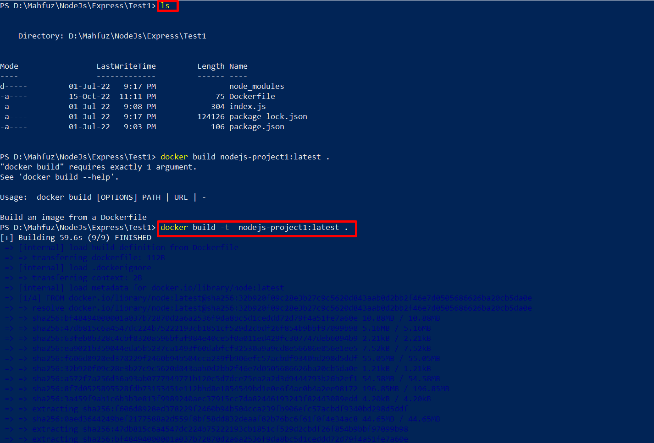

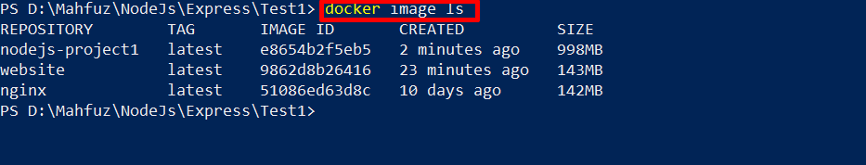

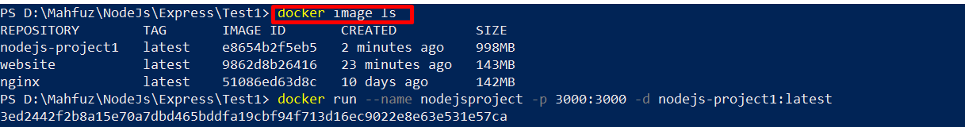



.Dockerignore

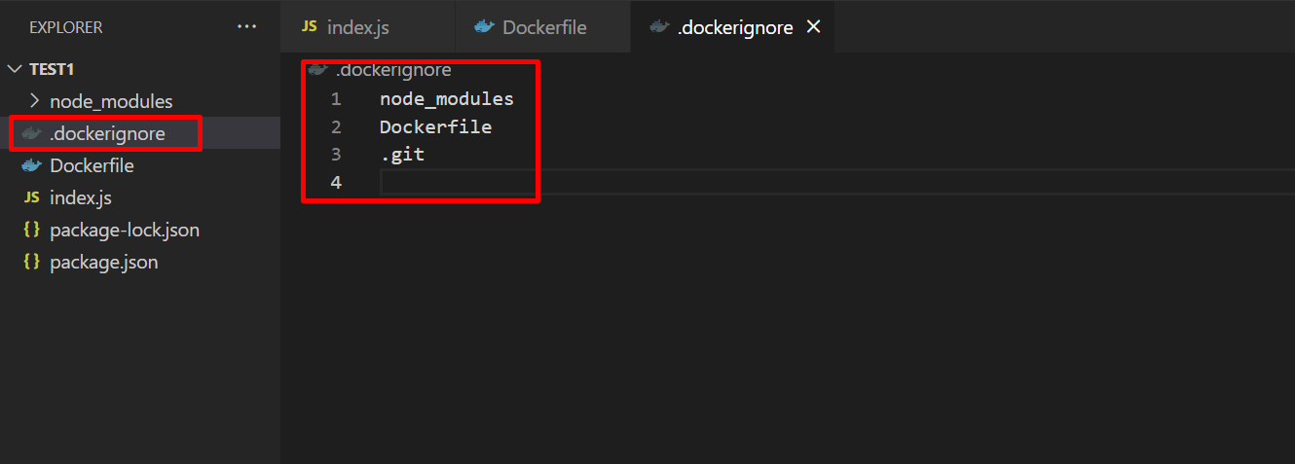

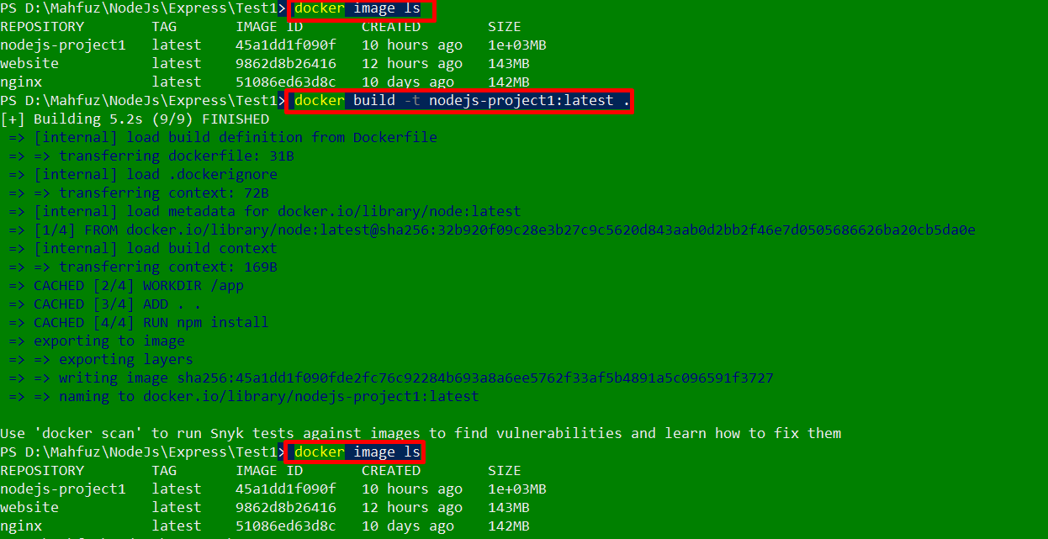

11. Chaching and Layers

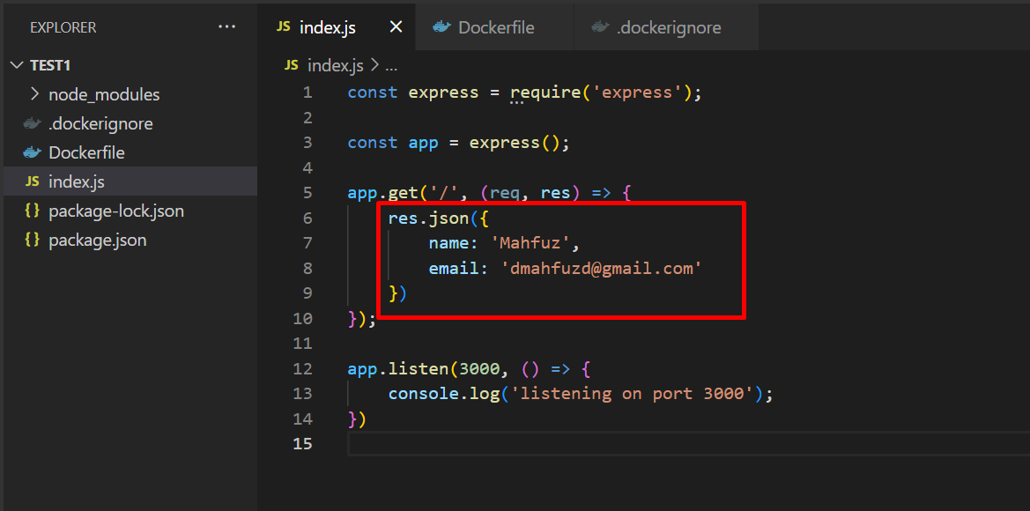

After change file content then build image

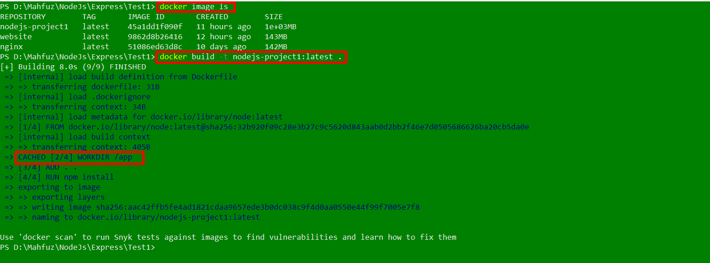

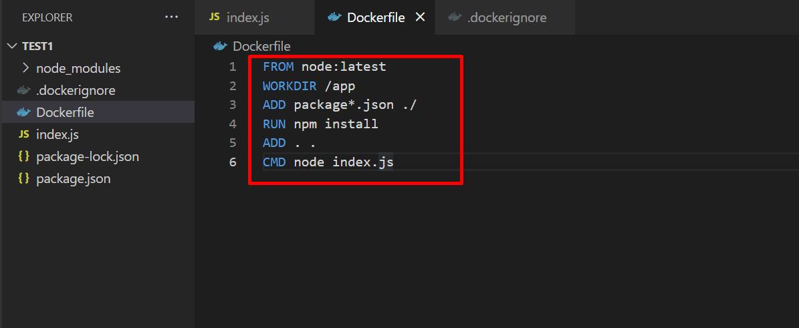

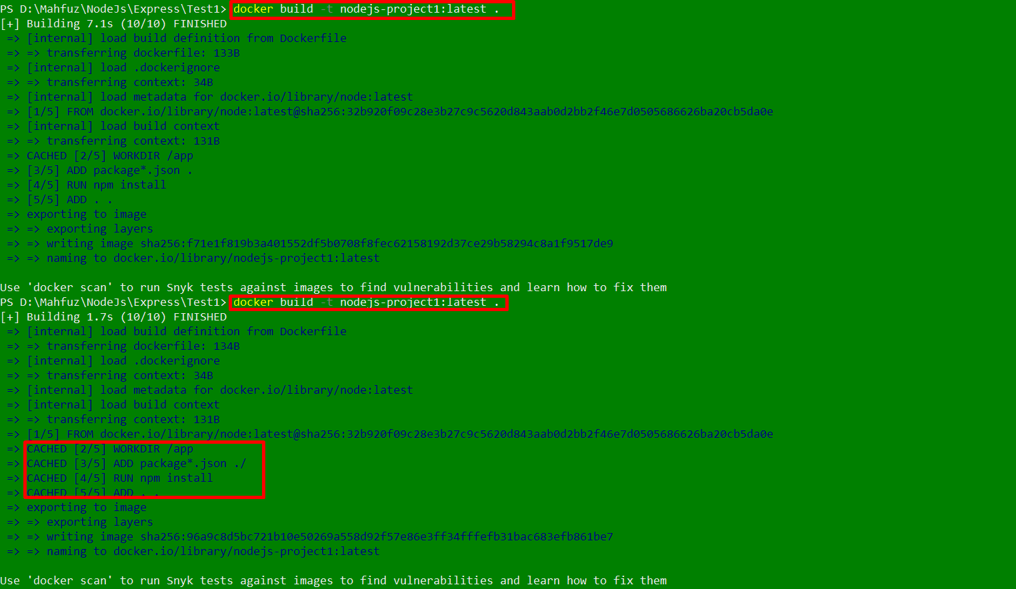

12. Reducing Image Size

Alpine

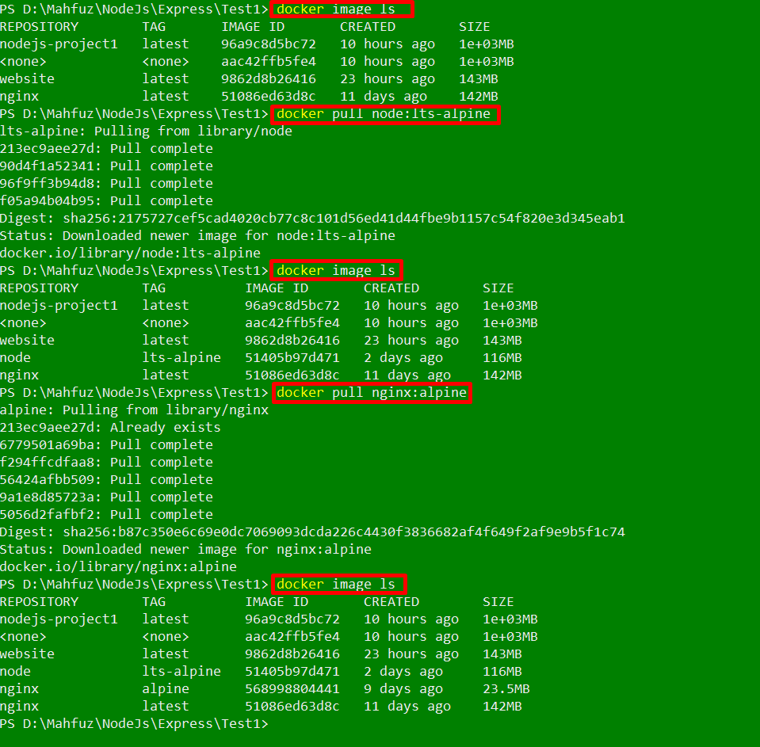

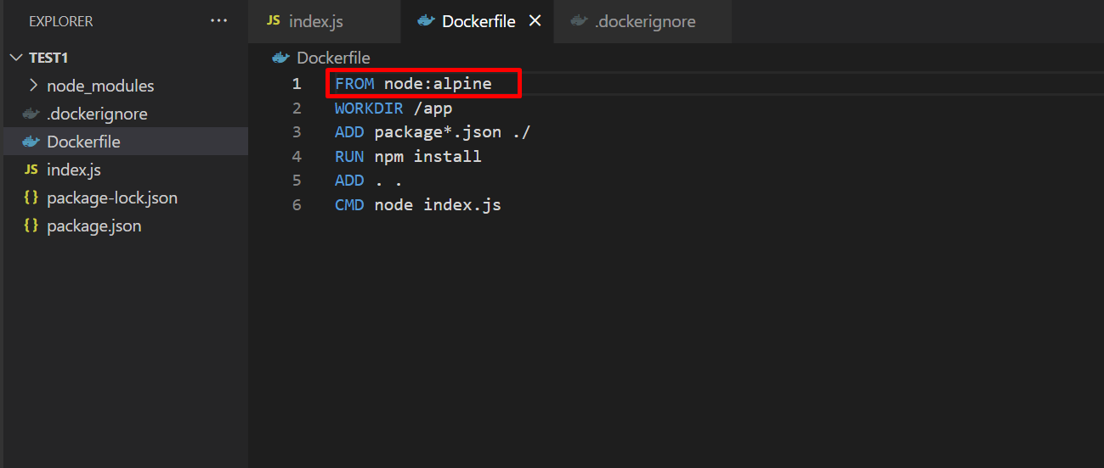

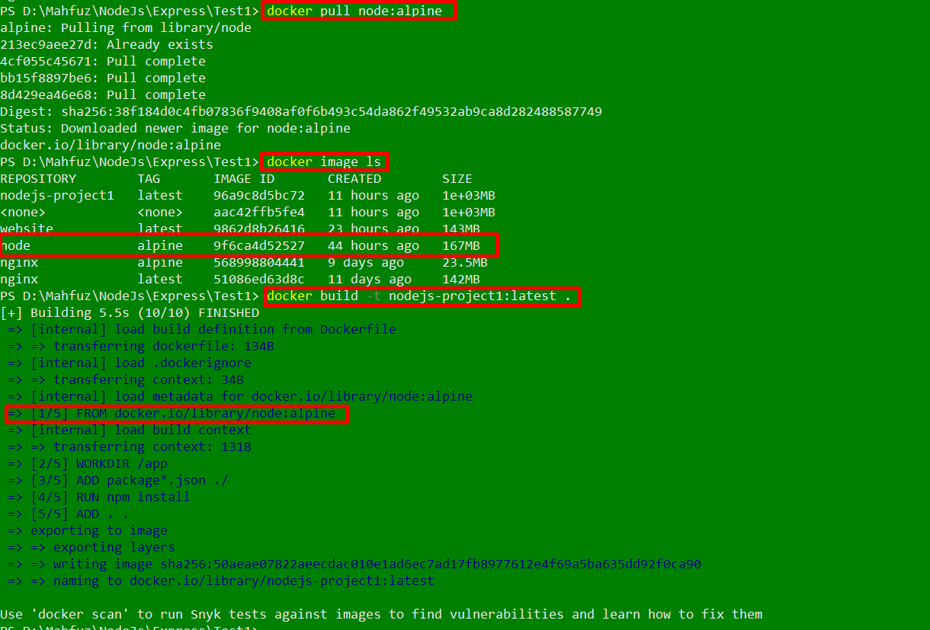

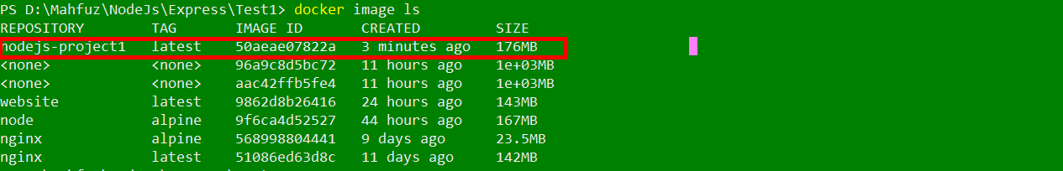

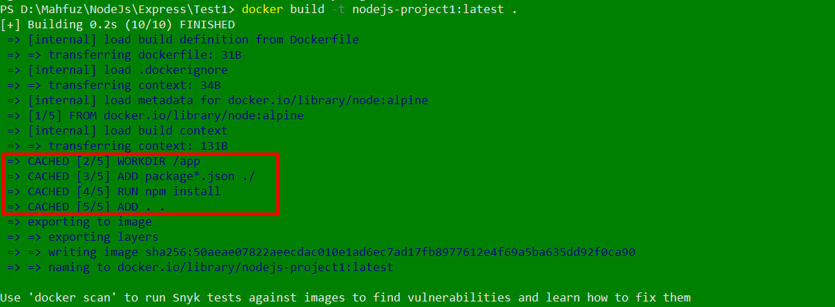

13. Tagging and versioning

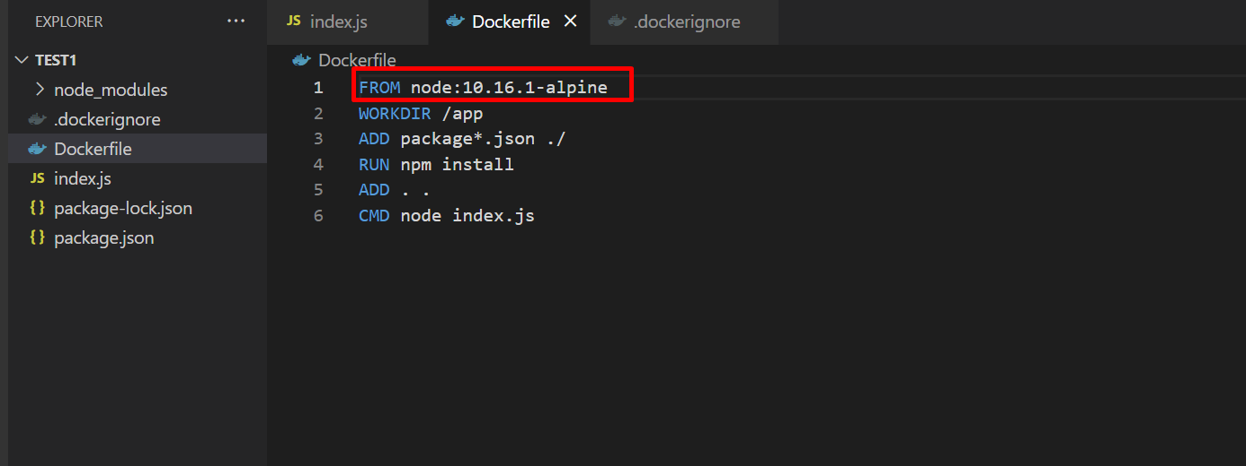

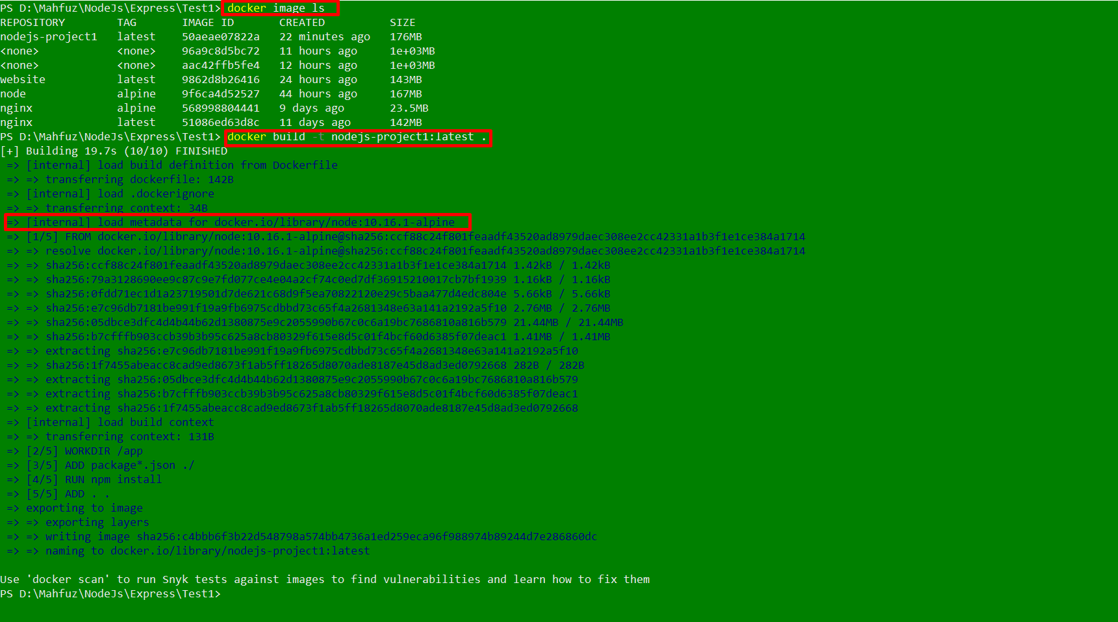

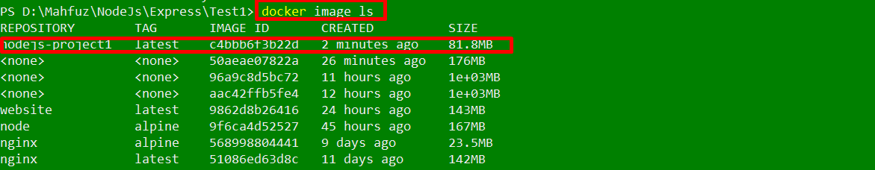

Tagging Images

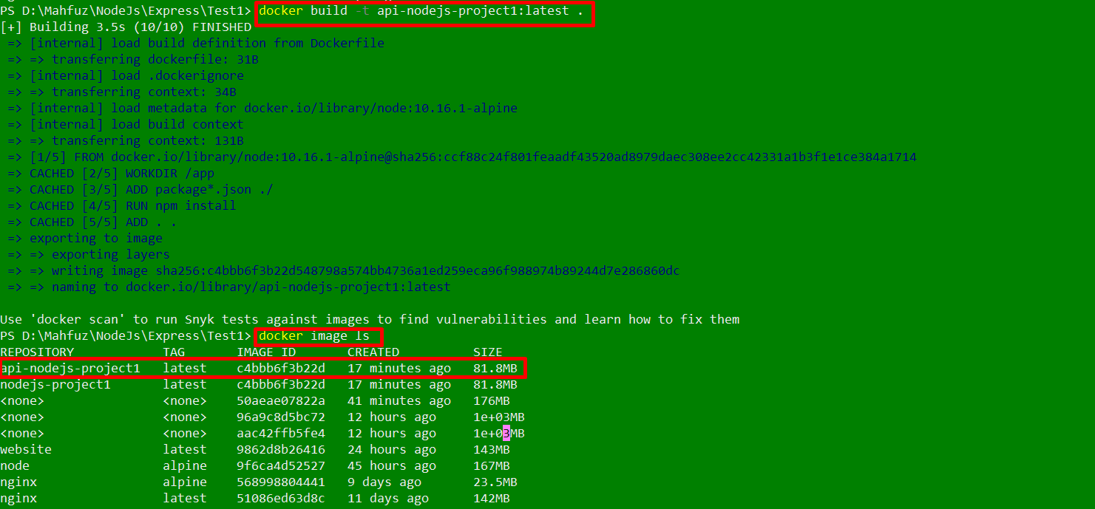

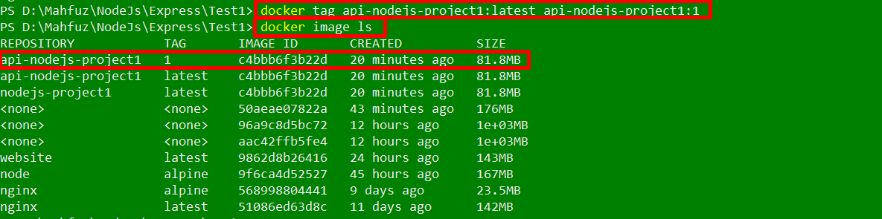

Running containers using tags

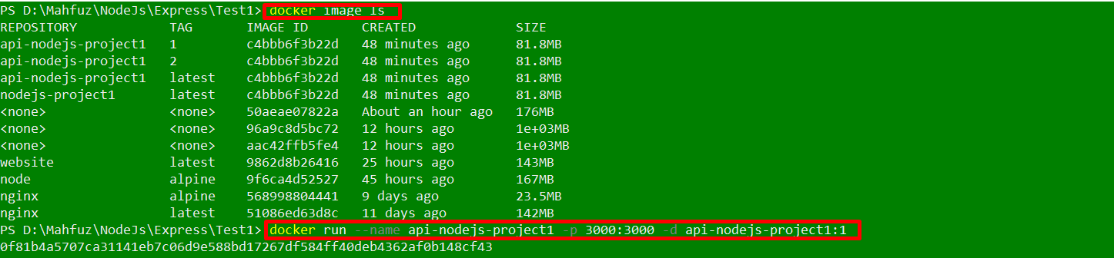

14. Docker Registries

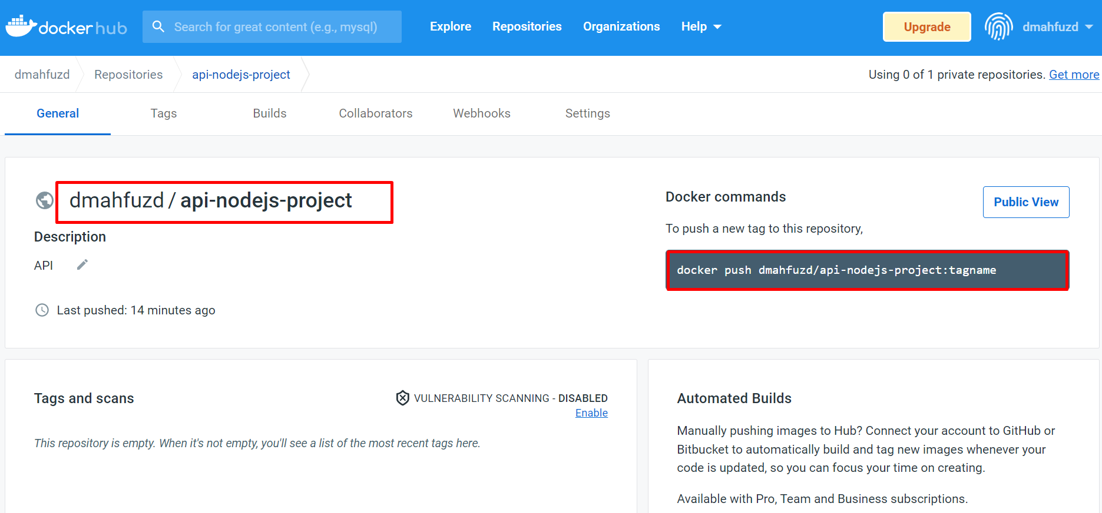

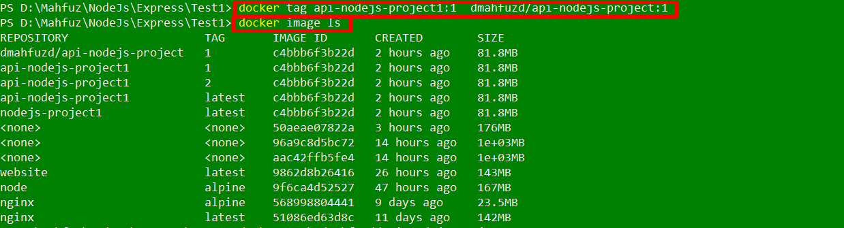

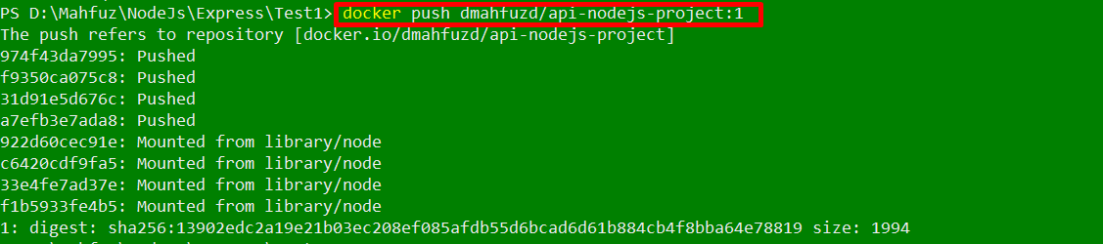

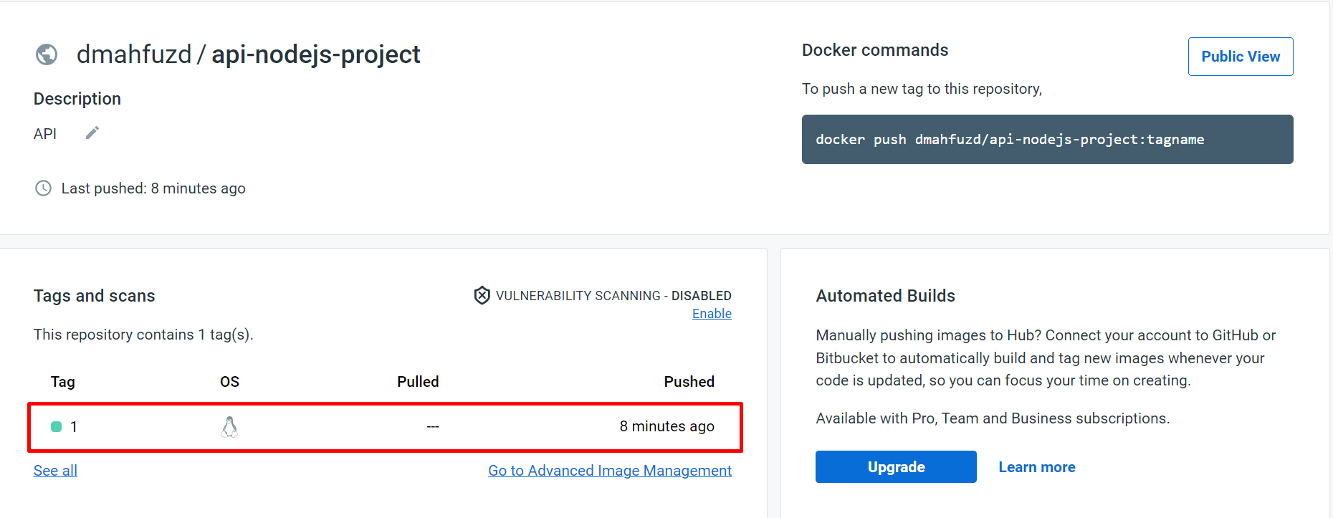

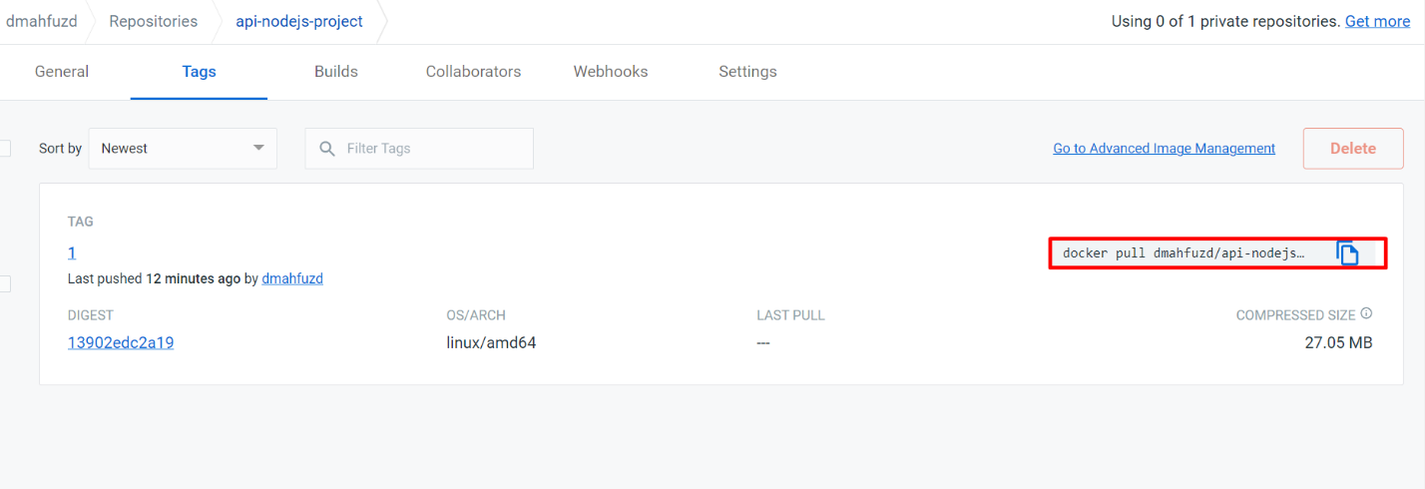

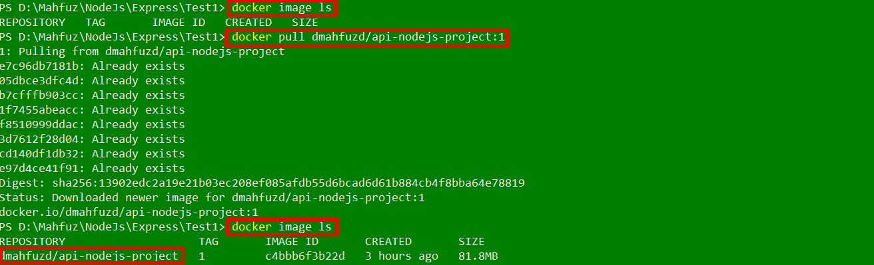



15. Debugging containers

Docker inspect

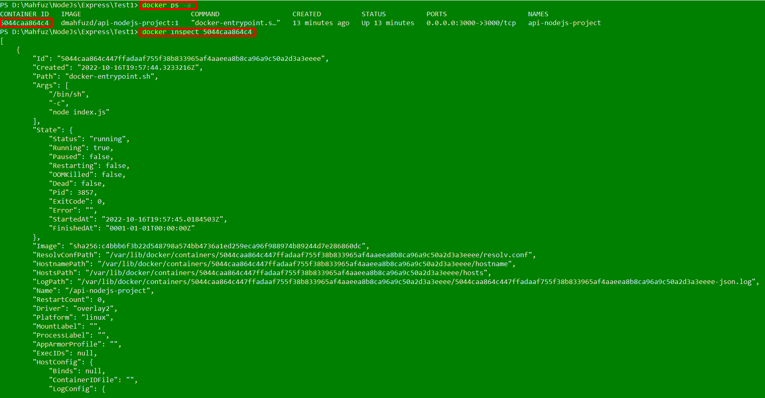

Docker logs



Bash into containers



